A
SEMINAR REPORT
ON
“PROPOSE SYSTEM FOR THE FILTERING CONTENT ON FACEBOOK”

CONTENTS
SR. NO. TOPIC PAGE NO.

- Abstract 5
- Introduction 6
- Classification of user 7
  - Characteristics of users 7
- Data Preparation 8
- Disadvantages of current system 9
- Filtering 9
  - content based filtering 10
  - collaborative filtering 10
  - hybrid filtering 10
- Related work 11
  - Predicting future banning 11
- Algorithm 12
- Flow chart 14
- Implementation 15
- System Requirement 16
- Advantages of propose system 16
Conclusion 17
References 18

1.0 ABSTRACT
Normally, Internet accessing is blessed with the mixed ones. It may create serious problem when accessing worst content. According to this incident we need some firewalls to protect ourselves from worst accessing of internet. Web Content Filtering is a type of firewall to block certain web pages from being accessed. One fundamental issue in today is On-line Social Networks (OSNs) is to give users the ability to control the messages posted on their own private space. This is to avoid unwanted content and a robust system allowing OSN users to have a direct control on the messages posted on their walls.

2.0 INTRODUCTION
Social media and online social networks (OSNs) represent a revolution in Web users behavior that is spreading at an unexceptional rate during the latest years. Online users aggregate on platforms such as Facebook and Twitter creating large social networks of millions of persons that interact and group each other. People create social ties constituting groups based on existing relationships in real life, such as on relatives, friends, colleagues or based on common interests, shared tastes, etc.
According to Facebook statistics average user creates 90 pieces of content each month, whereas more than 30 billion pieces of content (web links, news stories, blog posts, notes, photo albums, etc.) are shared each month. The huge and dynamic character of these data creates the premise for the employment of web content mining strategies aimed to automatically discover useful information dormant within the data. They are instrumental to provide an active support in complex and sophisticated tasks involved in OSN management, such as for instance access control or information filtering. Information filtering has been greatly explored for what concerns textual documents and, more recently, web content.
Content filtering used to give users the ability to automatically control the messages written on their own walls, by filtering out unwanted messages. Today OSNs provide very little support to prevent unwanted messages on user walls. For example, Facebook allows users to state who is allowed to insert messages in their walls (i.e., friends, friends of friends, or defined groups of friends). However, no content-based preferences are supported and therefore it is not possible to prevent undesired messages, such as political or vulgar ones, no matter of the user who posts them.

3.0 Classification of User:-
Basically we are categorizing online users into two type Future-Banned user (FBUs), Never-Banned User (NBUs). By analyzing language of their posts, we find significant differences between these two groups. For example, FBUs tend to write less similarly to other users, and their posts are harder to understand according to standard readability metrics. They are also more likely to use language that may stir further conflict ie they use vulgar language in their post, comment and chatting. FBUs also differ in how they engage in discussions: their posts tend to be concentrated in individual threads rather than spread out across several. They receive more replies than average users, suggesting that they might be successful in luring others into fruitless, time-consuming discussions.

3.1 Characteristics of users:-
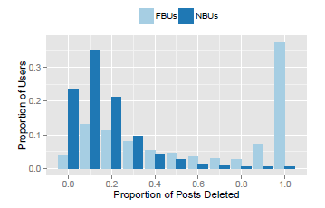
We observe that Proportion of a user’s posts that get deleted by moderators is very high as compared to NBUs. Some FBUs have high post deletion rates, while others have relatively low deletion rates. While both types of FBUs tend to write similarly overall, those with high post deletion rates write less similarly to other users in the same discussion thread and write more in each discussion they participate in, while those with low post deletion rates spread their posts across a larger number of discussions, and thus attract less attention.

3.1 Number of FBU users are increasing on the social networking site:
First, we note that FBUs tend to post more frequently than average users (prior to getting banned. To control for this large disparity in posting activity, we match a statistical technique used to support causality claims in observational studies, to control for the number of posts a user made and the number of posts made per day. In other words, for each FBU, or user who was later banned, we identify a similarly active user that was never banned.

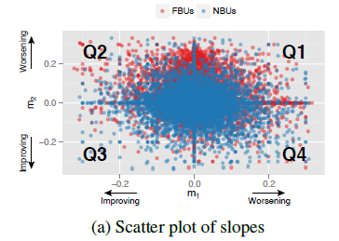

4.0 DATA PREPARATION
We investigated three online news communities: CNN.com (general news), Breitbart.com (political news), and IGN.com (computer gaming), selected based on their large size (Table 1). On these sites, community members post comments on articles, and each comment can either be replied to, or voted on. In this seminar report, we refer to comments and replies as posts, and to the list of posts on the same article as a thread. Discus, a commenting platform that hosts the discussions in these communities, provided us with a complete time stamped trace of user activity
From March 2012 to August 2013, as well as a list of users that were banned from posting in these communities.

Fig: Table shows the no .of banned users & their percentage
Community | # Users | #Users Banned | # Threads | # Posts | #Posts Deleted | #Posts Reported
CNN | 1,158,947 | 37,627 (3.3%) | 200,576 | 26,552,104 | 533,847 (2.0%) | 1,146,897 (4.3%)
IGN | 343,926 | 5,706 (1.7%) | 682,870 | 7,967,414 | 184,555 (2.3%) | 88,582 (1.1%)
Breitbart | 246,422 | 5,350 (2.2%) | 376,526 | 4,376,369 | 119,265 (2.7%) | 117,779 (2.7%)

- DISADVANTAGES:
- Text quality is low
- Large number of anti-social post & content is posting.
- FBU users are in large no as compare to NBU.
- Detecting antisocial behavior is difficult.
- School student used vulgar words in their conversation.
- College and school student attracted toward vulgar activities.

6.0 FILTERING:
Filtering is new subject in the technological area. This issue appears as consequences for the variety of media and advertisement in the internet web sites that lead to unethical and misuse of WWW users. Massive volume of internet content is widely accessible nowadays. One can easily view improper content at will without access control. A modern and effective web content filtering solution scans more than the name of its domain. It is able to break down and analyze web traffic making it capable to accurately pinpoint portions of a web page which should not be allowed into the internal network. There are three basic types of filtering techniques, which are used to filter the information on OSN.

6.1 Content-based:
Content based information filtering systems are used to filter only textual content on the OSN. Content based information filtering systems are not suitable for multimedia items, such as images, audio, video.
Content-based filtering more than often provides recommendation in a literal sense, because all the information is selected and recommended based on textual contents. Even though a product was essentially useful, it might be under-valued because of the ambiguous and thus misleading appearance of the textual contents. In addition, it is indistinguishable in quality of the recommended products. This is because the term vector for a product simply captures the frequency of each term in an article, and a poorly worded article can well have an equal or even higher similarity value than a finely written one.

6.2 Collaborative filtering:
Collaborative filtering systems filters information based on the interests of the user (past history), and the ratings of other users with similar interests. It is widely used in many filtering systems or recommender systems, especially in e-commerce applications. Examples of such systems are Amazon.com and e-Bay, where a users past shopping history is used to make recommendations of product.
Collaborative filtering are used to filter all types of items, including the multimedia items. It suffers from the cold-start problem and early rater problem. It involves the issues of filtering a new item, if it is not rated by any one of users yet. This system also suffers when data are sparse, which makes the recommendation difficult, as there are few common items present in calculating the similarity measures.

6.3 Hybrid Filtering Systems:
The hybrid filtering systems combines features of both the content and collaborative filtering systems. The hybrid system overcomes the problem of cold start and early rater problem by using the content based approach in the initial stage. In the subsequent stages, it uses collaborative filtering systems features, which helps the system to recommend all types of items, including multimedia items and overcomes the problem related to content based filtering techniques. It is the first simple combination model, which combines results from the collaborative and content-based filters as shown in following Fig

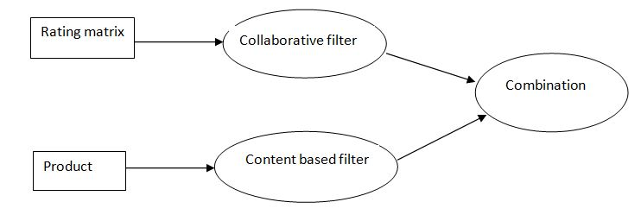
Fig Hybrid filtering

7.0 RELATED WORKS:
In this seminar or project we are working present an algorithm for filtering the Facebook content, for this purpose we are using an namely “An Early Decision Algorithm”. This algorithm accelerates the filtering process in the web content either to block or pass the web pages content. It is implemented using the testing samples of DansGuardian. This work addresses the problem of long delay from text classification algorithms to perform the runtime content analysis of web content.

7.1 Predicting future banning
We show that a user’s posting behavior can be used to make predictions about who will be banned in the future. Inspired by our experimental analysis, we design features that capture various aspects of antisocial behavior: post content, chatting with friends, user activity, community response, and the actions of community moderators. We only need to observe 5 to 10 user’s posts before a classifier is able to make a reliable prediction. Further, cross domain classification performance remains high, suggesting that the features indicative of antisocial behavior that we discover are not community-specific.

8.0 ALGORITHM
This is an algorithm which makes a filtering decision on the web pages content. Because, massive volume of Internet content is widely access now-a -days. One can easily view improper content at will without access control. Web filtering products can enforce the access control. This algorithm analyzes the Web content to a certain category first, and makes the filtering decision, either to allow or ban the content. The filtering work of this algorithm present a simple, but effective in the form of observation that the filtering decision can be made scanning through the entire content of the web page, as soon as the content can be analyzed into a certain category.
In the filtering stage, given n% of the content that has been scanned and the score m or less that has been accumulated, the probability that the content should belong to a category c is derived fro
P (D (n,m)|c) P(c)
P(c|D(n,m))= P(D(n,m)|c) +P(D(n,m)|c’) P(c’)

1. D(n,m) : the event that the filter has read n% of the content and has observed the score accumulation m or less.
2. P(c) : the estimated probability that category c appears in typical Web content.
3. P(c' ) : the estimated probability that category c does not appear in typical Web content. P(c' ) = 1 - P(c) .
4. P(D(n,m) | c) : the estimated probability that D(n,m) happens given that the content belongs to category c. The estimate of P(D(n,m) | c) is the number of Web pages in c that D(n,m) happens divided by the number of Web pages in c.
5. P(D(n,m) | c' ) : defined similarly as P(D(n,m) | c) , except that c is replaced with c’. The values of P(ci) and P(ci’) can be estimated beforehand or dynamically tuned in a running environment by recording and analyzing actual Web content.
Two thresholds, Tbypass and Tblock, are defined to be 0.1 and 0.9 herein. PCDi is the estimate that the content should belong to a category ci. If PCDi is less than Tbypass for all ci in the list of banned categories, this means the content is unlikely to be banned and the remaining content should be bypassed. In contrast, if there exists some ci in the list of banned categories such that PCDi is larger then Tblock, this means the content is likely to belong to ci and should be blocked by the filter.
A minimum of the content should be scanned in the process to avoid deciding too early from only the little front part of the content, which may render the filtering result incorrect. The algorithm is
Early bypass ← False;
Early block ← False;
N← 0;
Do {
Read next keyword;
// Skip stop words and the HTML tags.
n ← the percentage of content that has been scanned;
m ← the accumulated score;
If (n→ Min_Scan)
{
// scanning at least Min_Scan% of document,
// Min_Scan=10 herein
For (each category ci in the set of banned categories)
{
PDCi ← P(D(n, m)|ci) of current scanning position;
PDCi’ ← P(D(n, m)|ci’) of current scanning position;
PCDi ← (PDCi*P(ci))/(PDCi*P(ci)+PDCi’*P(ci’));
}
// end of For
If (for all category ci, PCDi ← Tbypass)
{
Earlybypass:=True;
Exit;
}
If (for some category ci, PCDi → Tblock)
{
Earlyblock: =True;
Exit;
}
} // End of If (n > Min_Scan)
While (not end of content);

9.0 Flow chart:

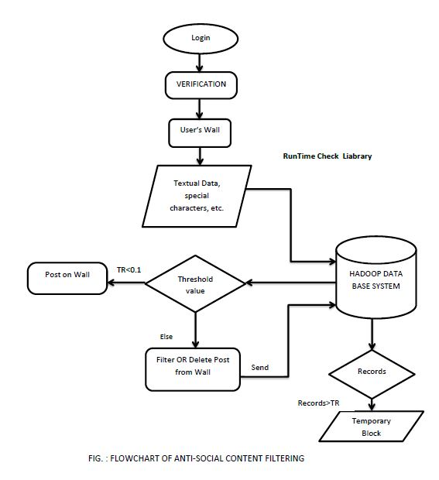

10.0 IMPLEMENTATION:

For a sample, totally 5 users are randomly taken and extracted the page content (text) through the corresponding URLs in real time (online or offline). Some keywords are selectively approaches to the filter for the process. (Note: According to this sample investigation the selected keywords are assume to be a Bad keywords to ban the pages).

The following Table represents the overall values for the given pages and the Following figure shows Graphical Representation of the corresponding results.

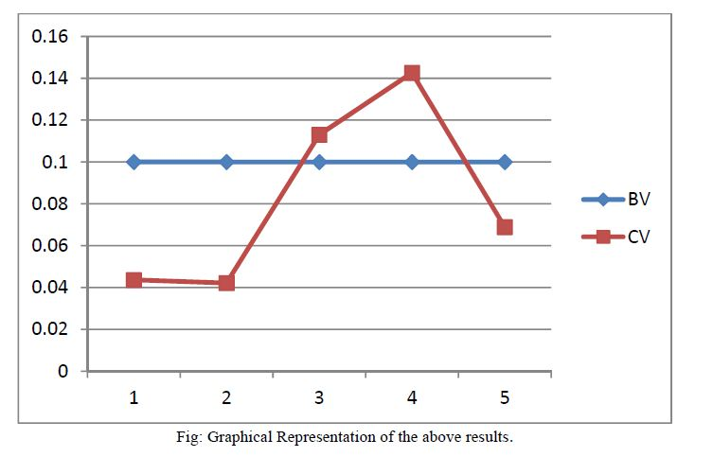
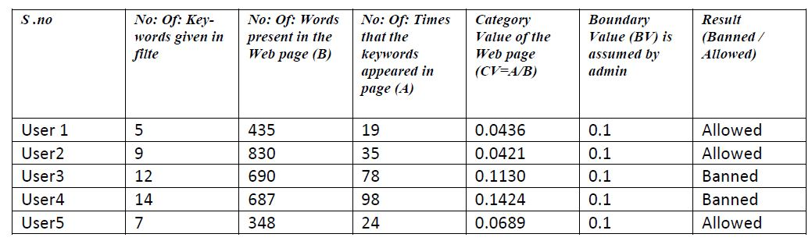
Fig.- No. of Banned users
Fig - Graphical Representation of Banned Users

The above figure is a Line Graph which represents the measures of content filtering algorithm. According to the graph, CV stands for Categorical Value of the web page which is calculated by the KT-Grand algorithm and BV stands for Boundary Value assumed by the Admin. There are two parameters are used, they are Serial number of the webpage on x-axis and Accurate Value of the web page calculated by the algorithm on y-axis. From the above graphical output the user 1, 2&5 are allowed to post their content on Facebook because values of their content is lower than the boundary value and user 3, 4 are banned from Facebook because values of their content is greater than the boundary value.
- .0 System Requirement:
- Sample data
- System must have 4 GB OF RAM
- 64 bit RAM required for maximum utilization of RAM.
- VMWare of version 10 and above must be install in a system
- Linux operating system 14.1 LTS version is required.
- HADOOP version 5.0 or CloudDera is required.

11.0 Advantages :
- System removed the antisocial content
- Reduced the number of FBU user
- Reduced the chances of spreading the antisocial activities
- Predicting future banning of the FBU user.
- Controlling the Antisocial behavior.
- Detecting antisocial behavior.
- Measuring text quality.

CONCLUSION:
We are developing a system to filter undesired messages (vulgar content) from OSN Facebook. This system then intern restricts the unwanted messages hence called as the Content Filtering System. We have dis-cussed the idea about filtering system. We have applied text filtering algorithms at pre- processing stage so as to categorize the messages like political, violence, vulgar etc. In our proposal, we will calculate threshold value for each message.

REFERENCES :
- T. Almeida, A. Yamakami, and J. Almeida, “Filtering spam’s using the minimum description length principle,” in Proceedings of the 25th ACM Symposium On Applied Computing, Sierre, Switzerland, March 2010, pp. 1–5
- T. Almeida, A. Yamakami, and J. Almeida, “Evaluation of approaches for dimensionality reduction applied with naive bayes anti-spam filters,” in Proceedings of the 8th IEEE International Conference on Machine Learning and Applications, Miami, FL, USA, December2009, pp. 1–6.
- I. Androutsopoulos, G. Paliouras, and E. Michelakis, “Learning to filter unsolicited commercial e-mail,” National Centre for Scientific Research “Demokritos”, Athens, Greece, Tech. Rep. 2004/2, March.
- Arasu, A. and Garcia-Molina, H (2003). Extracting Structured Data from Web Pages. SIGMOD-03.
- A. Bratko, G. Cormack, B. Filipic, T. Lynam, and B. Zupan, “Spam filtering using statistical data compression models,” Journal of Machine Learning Research, vol. 7, pp. 2673–2698, 2006.
- Cao, Jiuxin , Mao, Bo and Luo, Junzhou, 'A segmentation method for web page analysis using shrinking and dividing', International Journal of Parallel, Emergent and Distributed Systems, 25: 2, 93— 104, 2010.

